The purpose of this communication network is to provide a means of moving data from three internal measurement units (IMUs), through the system, to the destination which is the processing simulation. This communication network consists of 4 distinct sections; the data extraction block, data processing block, FPGA wireless communication block and the processing communication block. **Figure n** provides an overview of how the data moves across hardware before it arrives in the processing simulation.

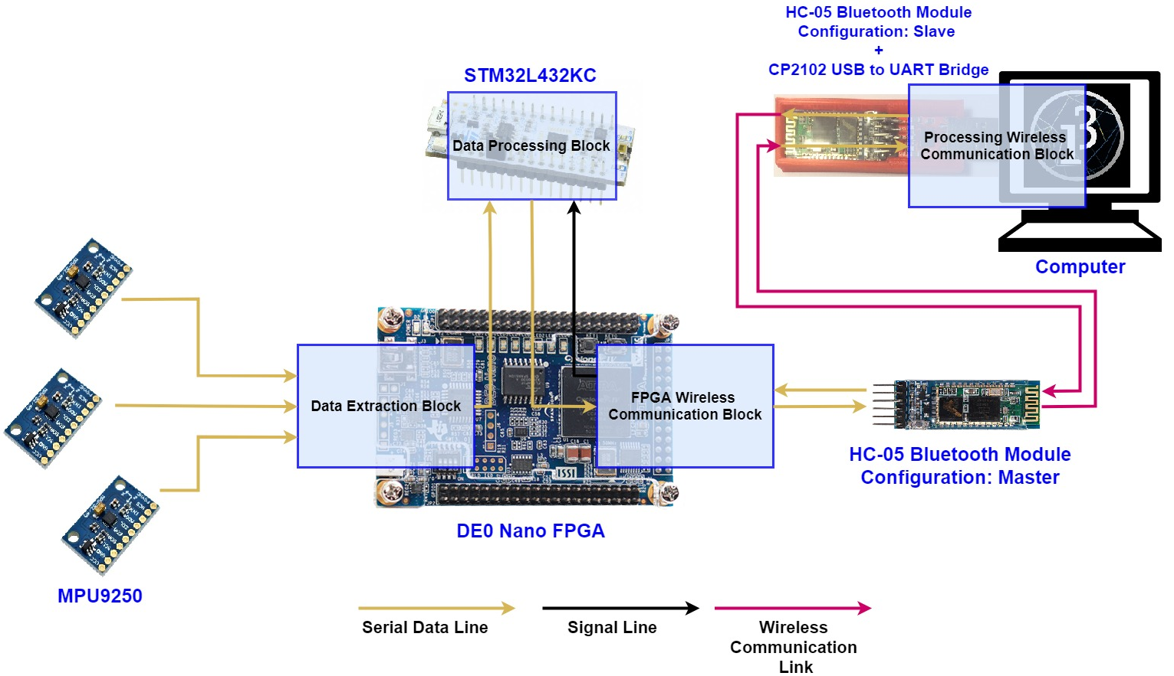

Figure n: Diagram depicting the flow of data across hardware.

Each block transforms the data in its own way in the communication chain. The aim of this section is to describe in detail how data is passed around the network, the components developed and how they work, how data is transformed along the process and the reasoning for the transformation and to provide evidence of functionality.

Wireless communication requirements summary

* The Bluetooth module uses the UART protocol to transmit data which means that each floating-point orientation data needs to be split into four 8-bit chunks in order to be able to transmit the data wirelessly.
* The data needs to be transferred from the FPGA to the HC-05 Bluetooth module and since it uses the UART protocol, an FPGA UART transmitter needs to be developed.
* On the receiving end of the wireless communication the simulation program needs to be able to identify which IMU the data received belongs to and how to turn back into useful information. Therefore, an adequate identification system needs to be developed in order to enable the simulation program to make sense of the data.
* Once the FPGA receives data from the STM32L432 it needs to organise the data for transmission.
* Since the Bluetooth wireless transmission creates a bottleneck in the system with maximum UART speed of 115200 bits per second or 14,400 bytes per second, the wireless communication block needs to be able to control the dataflow to itself such that data is not transferred to the block faster than it can transmit it.

The first component to be designed for this block was the “Wireless Communication Controller”